SKR & SKR GOVT DEGREE COLLEG WOMEN (A), KADAPA
PERFORMING ARTS
A COMMUNITY SERVICE PROJECT
Submitted to


SKR & SKR GOVERNMENT DEGREECOLLEGE FOR WOMEN (A)
KADAPA, Y.S.R DISTRICT
NAAC Re Accredited Institution at ‘B’ Level
(Affiliated to YOGIVEMANA UNIVERSITY)

DEPARTMENT OF TELUGU
COMMUNITY SERVICE PROJECT (CSP)
Submitted By
S.ASMABI, I BSC (BMC)
(HALL TICKET NO: 21440315052)
MENTOR
O.GEETHA MA.,
LECTURER IN TELUGU
SKR & SKR GOVERNMENT DEGREECOLLEGE FOR WOMEN (A)
KADAPA, Y.S.R DISTRICT
(2021 - 22)
CERTIFICATE

This is to certify that the project entitled
“Performing Arts in Kadapa”
is the Bonafede project work of

S.ASMABI, I BSC (BMC)
(HALL TICKET NO: 21440315052)
done under supervision of

O.GEETHA MA.,
LECTURER IN TELUGU
For the Community Service Project in the Department of TELUGU

HOD MENTOR

ACKNOWLEDGEMENT

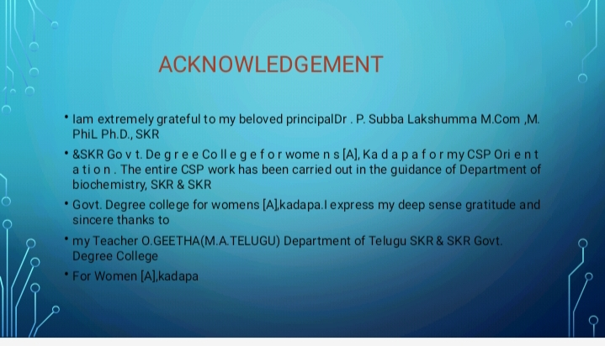

CONTENTS

S.NO | CHAPTER | PAGE
1 | I. INTRODUCTION
2 | II. TYEPS OF ARTS
3 | III. ABOUT THE AREA
4 | IV. RESULTS AND DISCUSSION
5 | V. CONCLUSIONS
6 | GEO-TAGGED PHOTOS
I. INTRODUCTION

The performing arts are arts such as music, dance, and drama which are performed for an audience.^{[1]} It is different from visual arts, which is the use of paint, canvas or various materials to create physical or static art objects. Performing arts include a range of disciplines which are performed in front of a live audience, including theatre, music, and dance.
Theatre, music, dance and object manipulation, and other kinds of performances are present in all human cultures. The history of music and dance date to pre-historic times whereas circus skills date to at least Ancient Egypt. Many performing arts are performed professionally. Performance can be in purpose built buildings, such as theatres and opera houses, on open air stages at festivals, on stages in tents such as circuses and on the street.

II. TYEPS OF ARTS



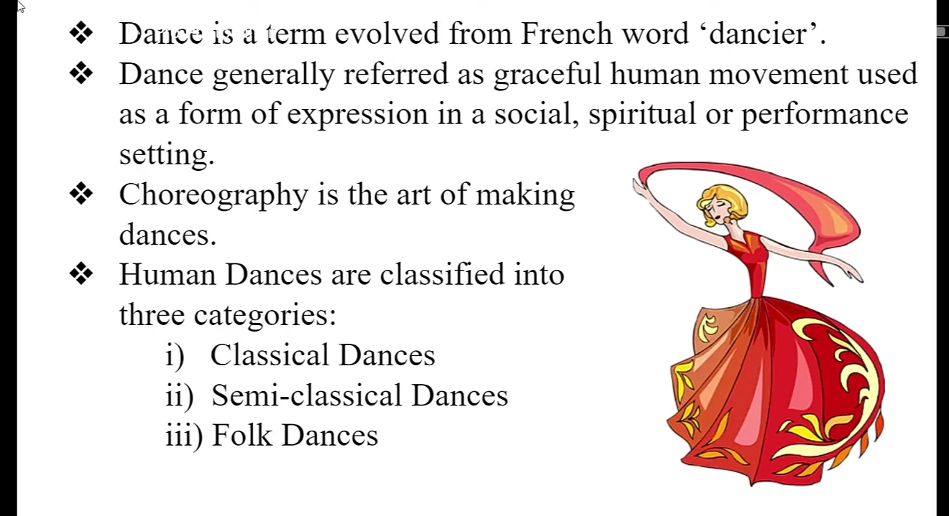

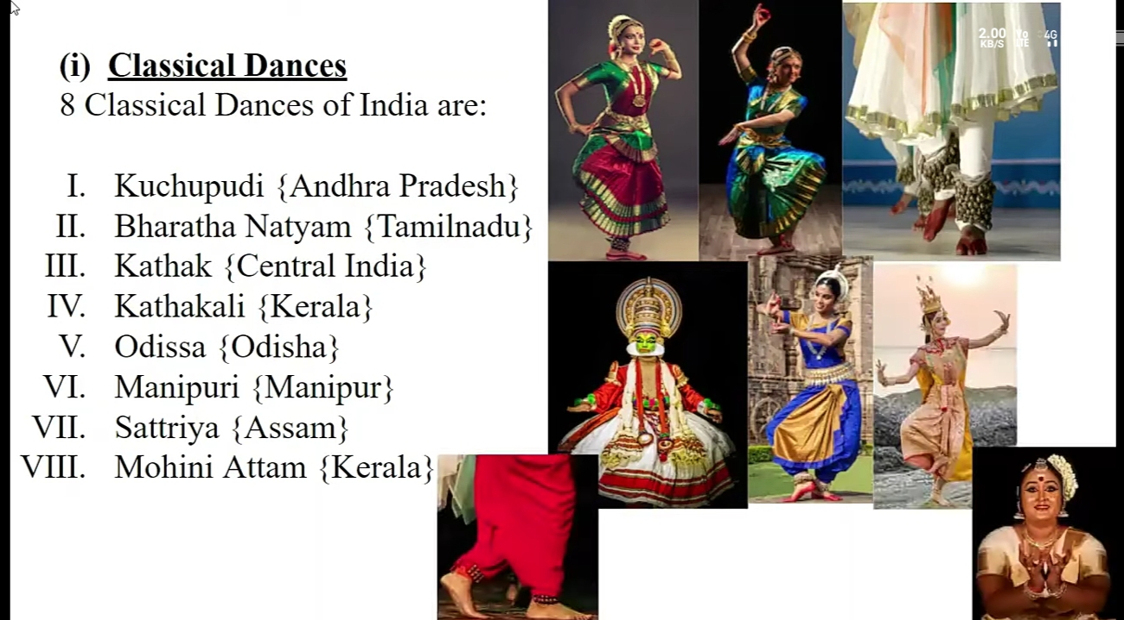

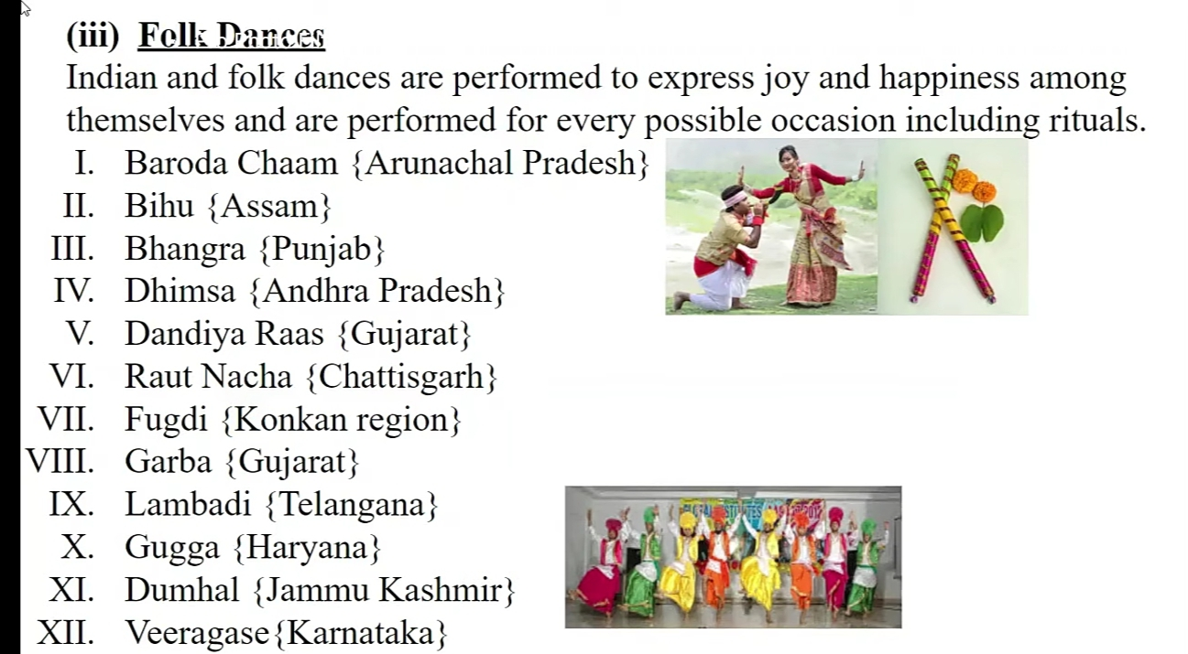

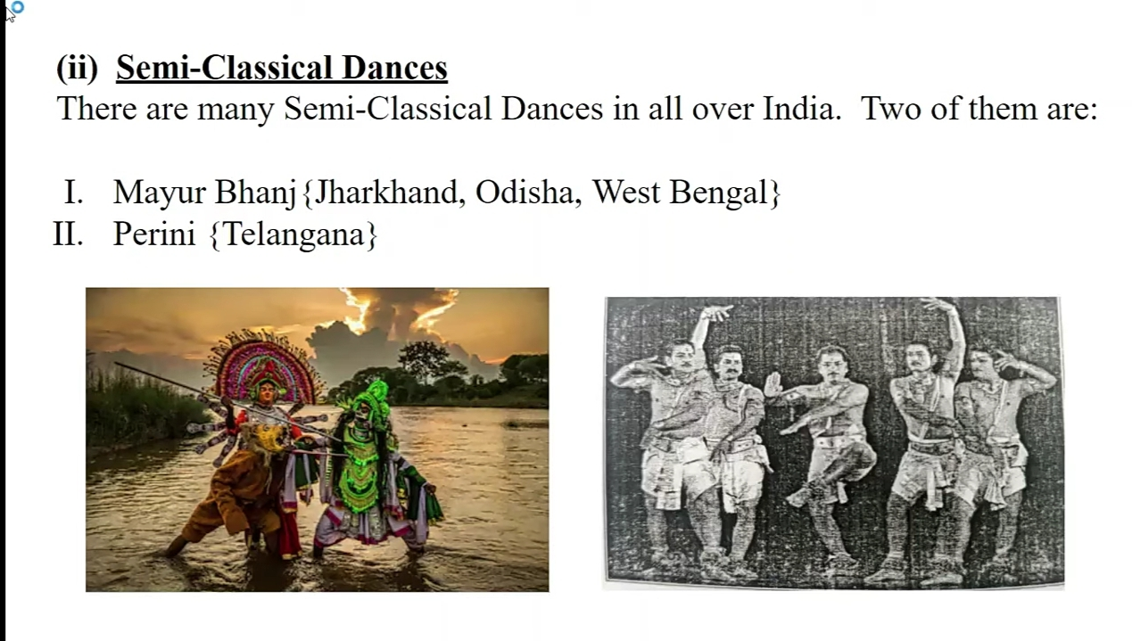



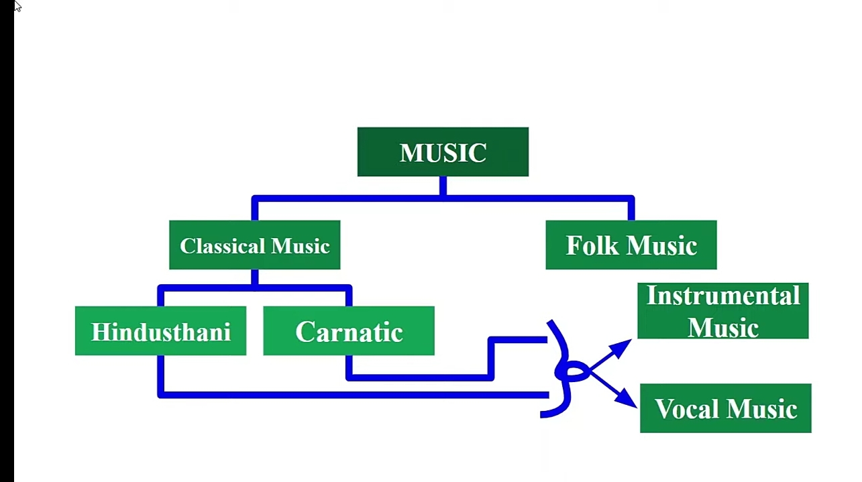

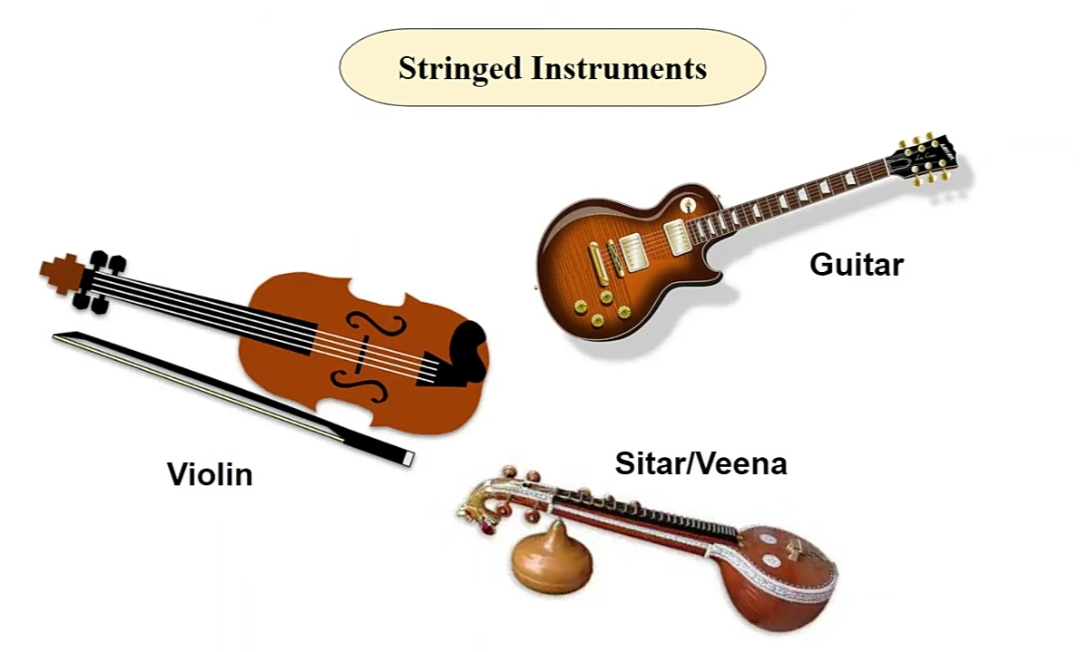

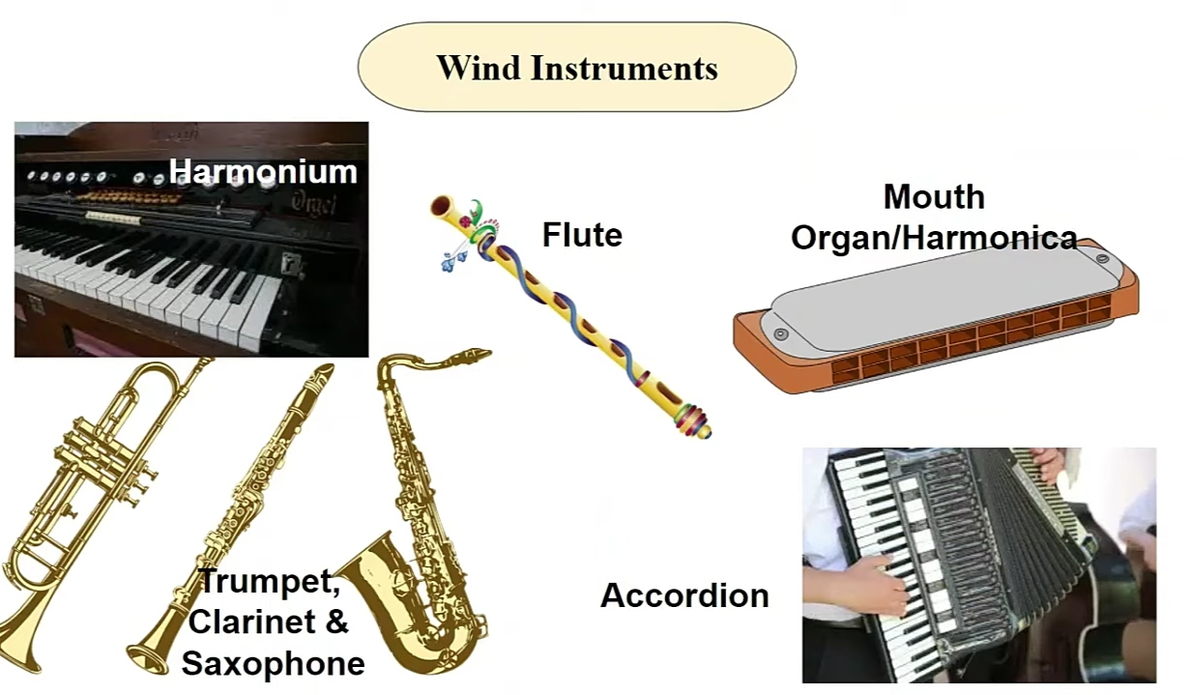

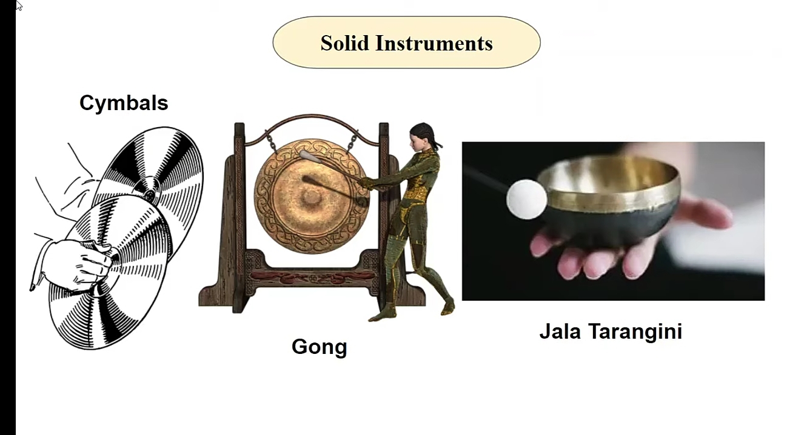

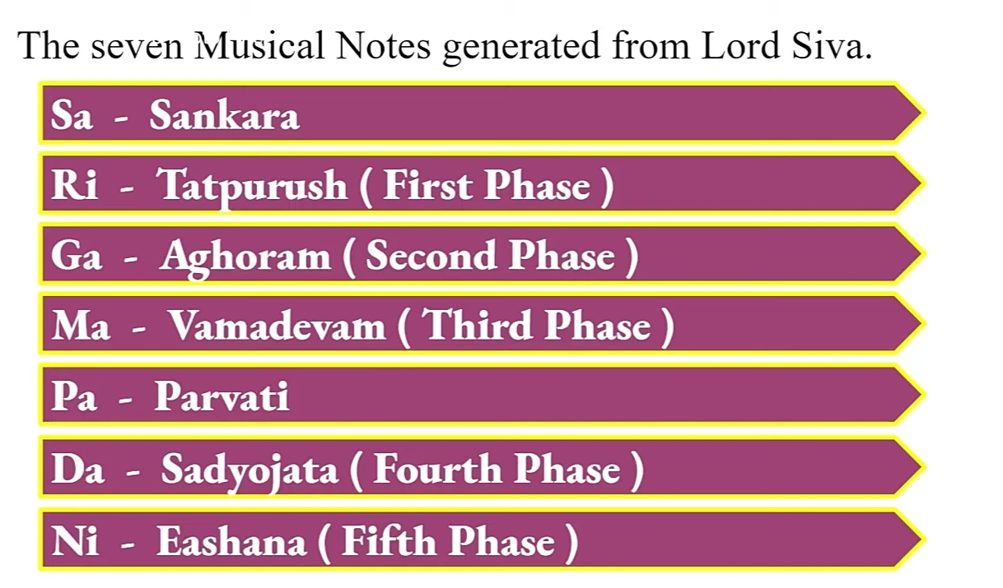



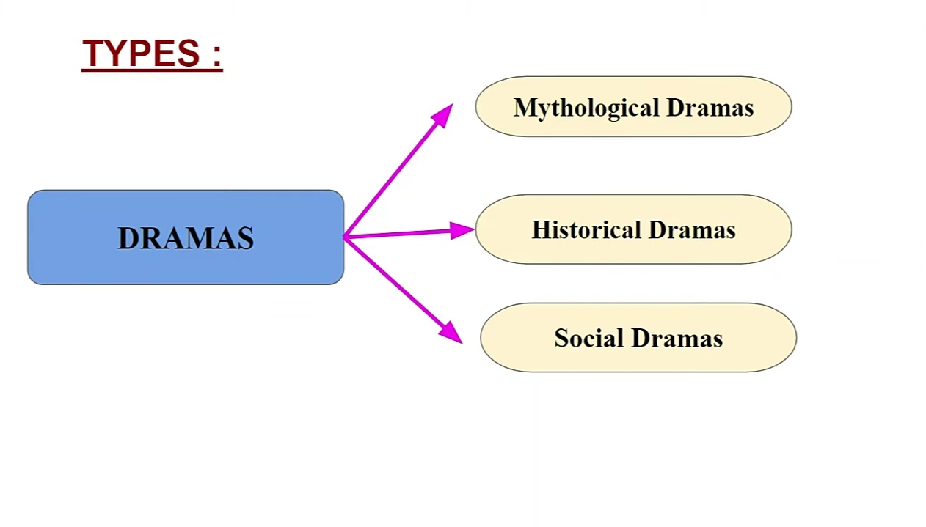

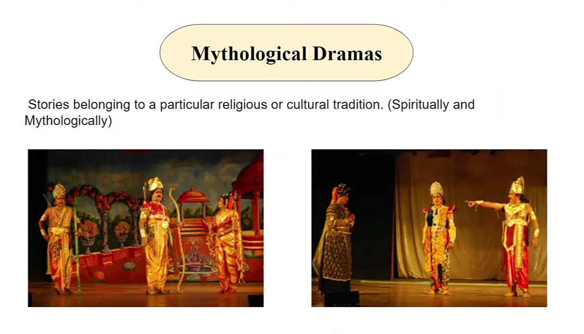

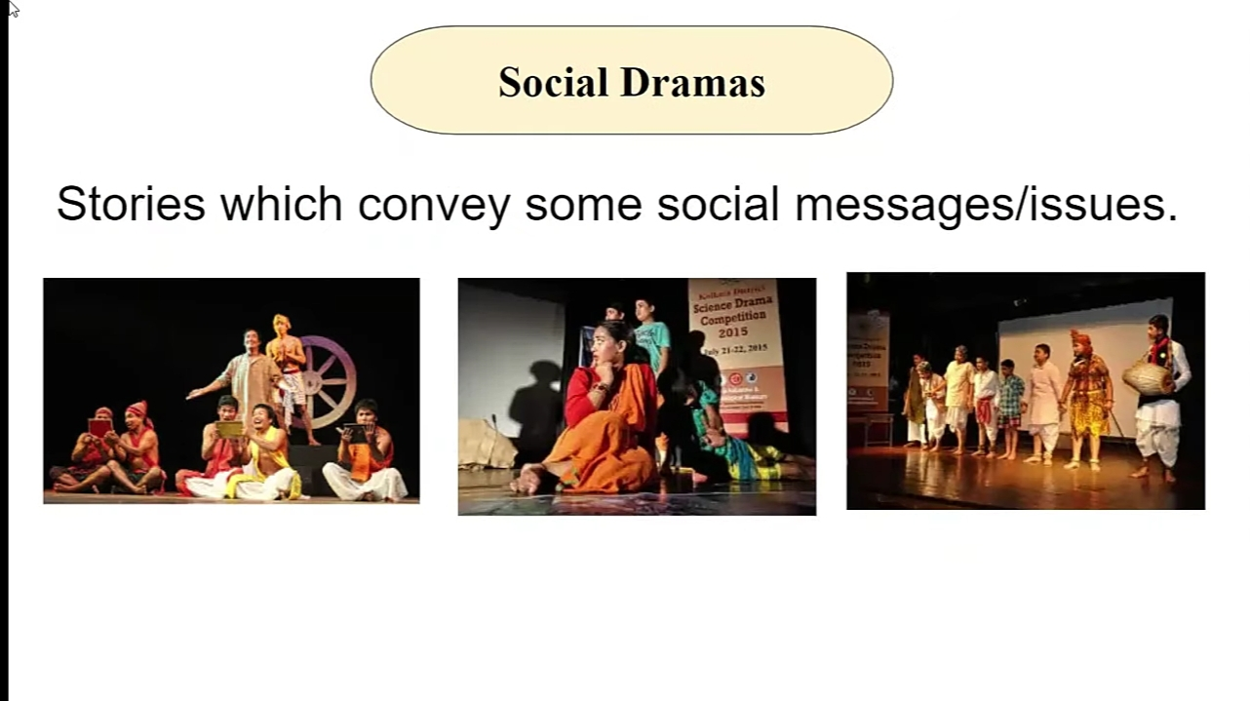

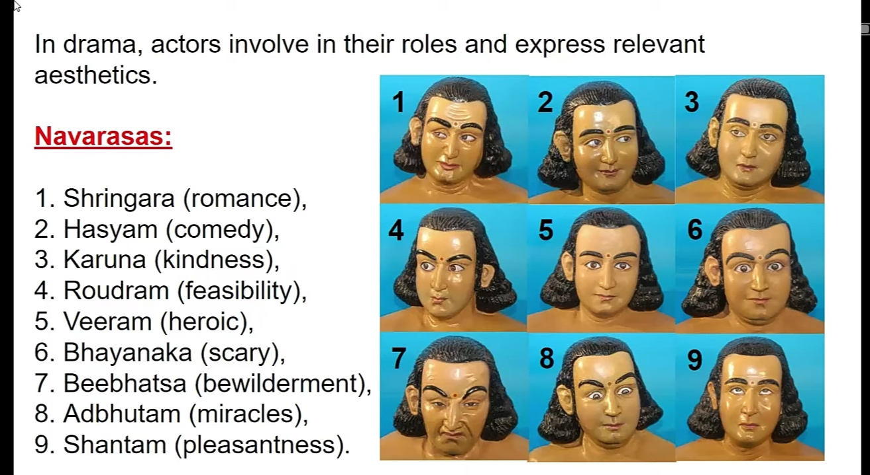

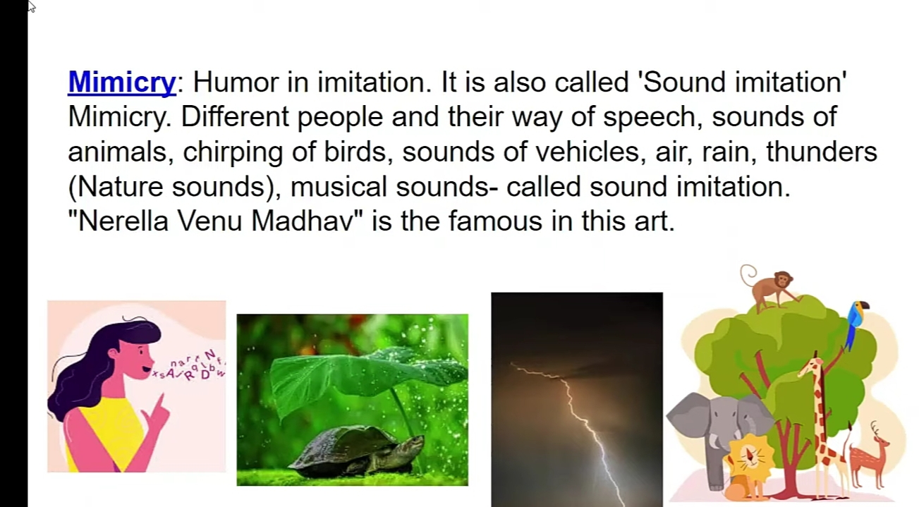



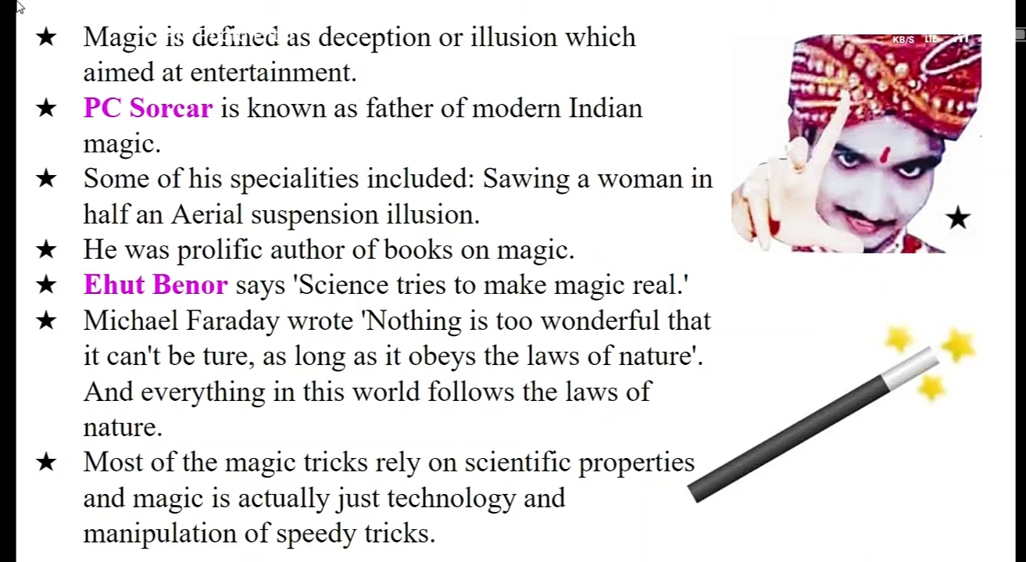



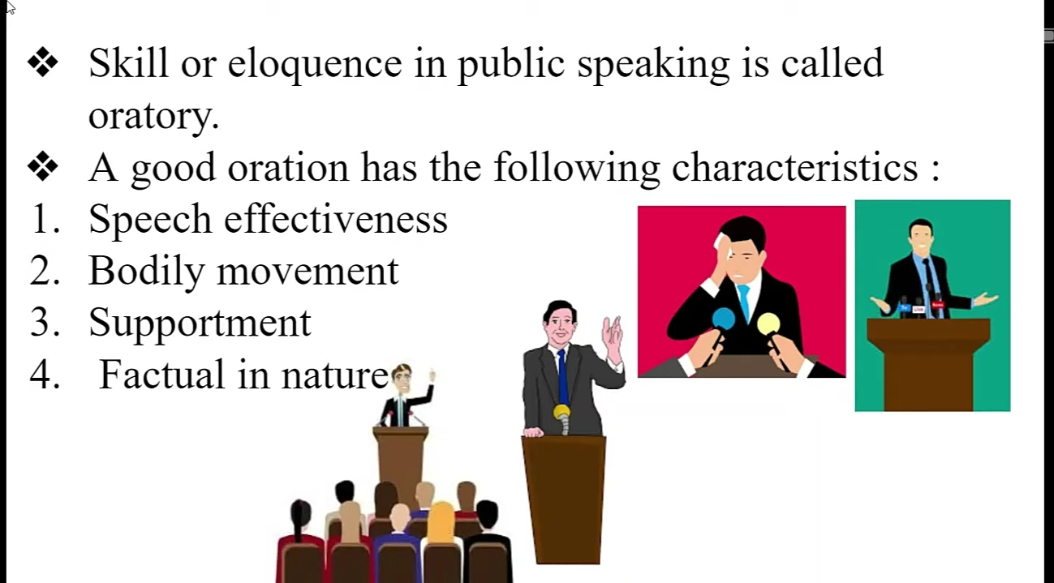



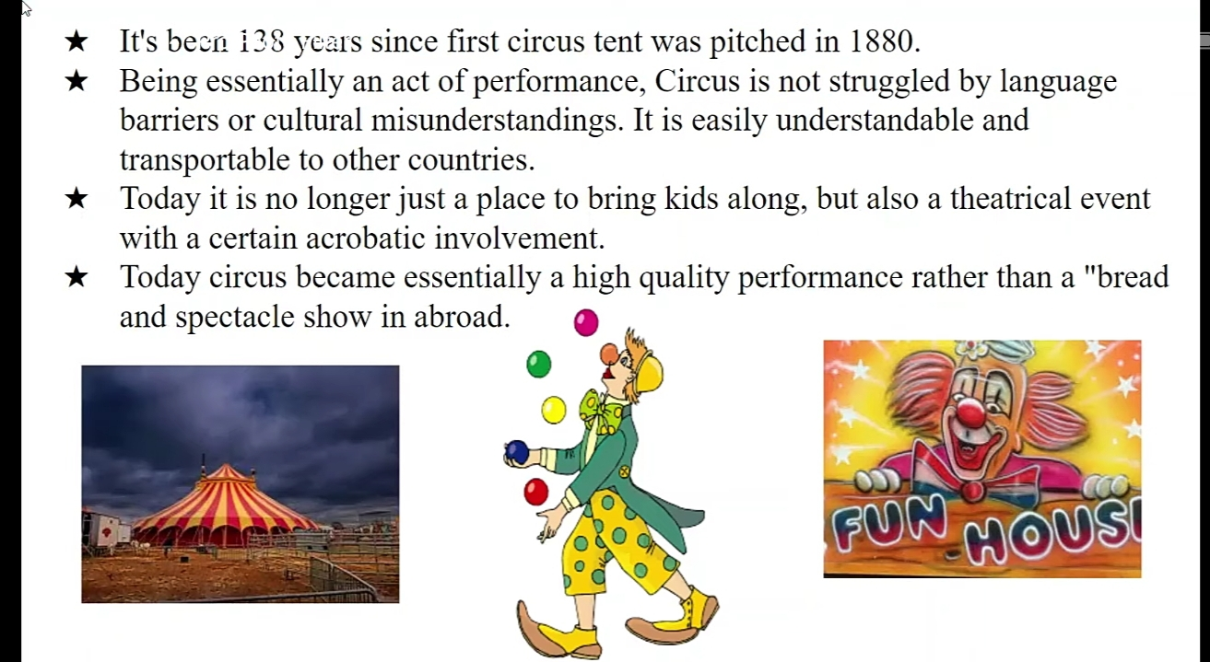





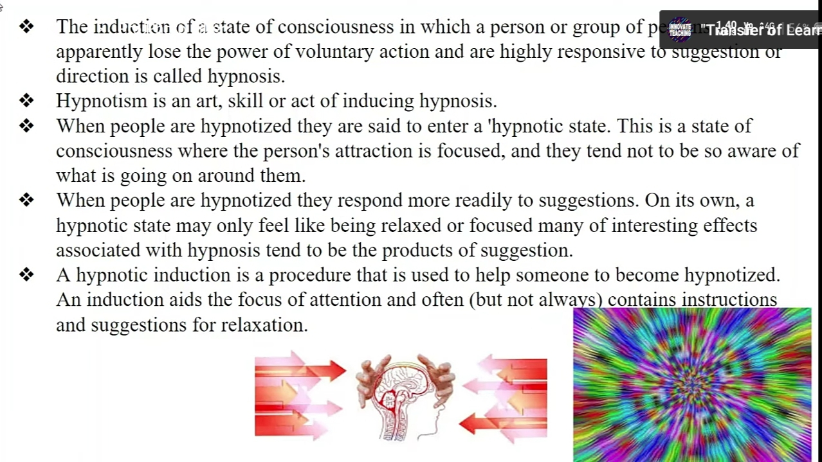

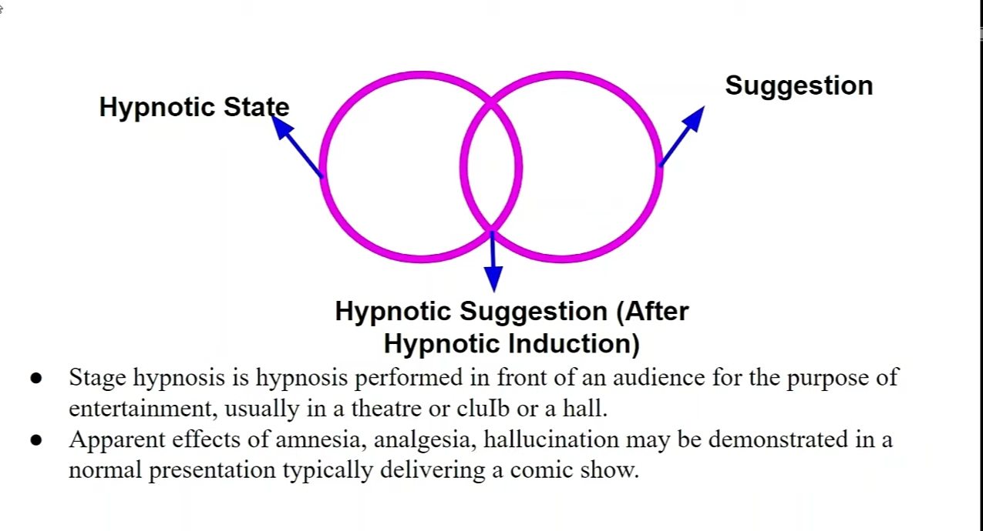
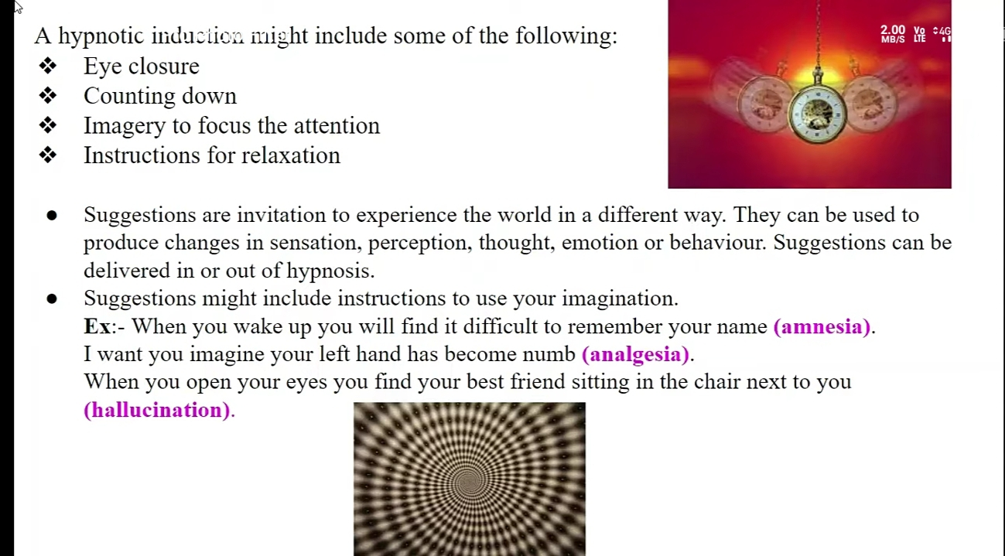



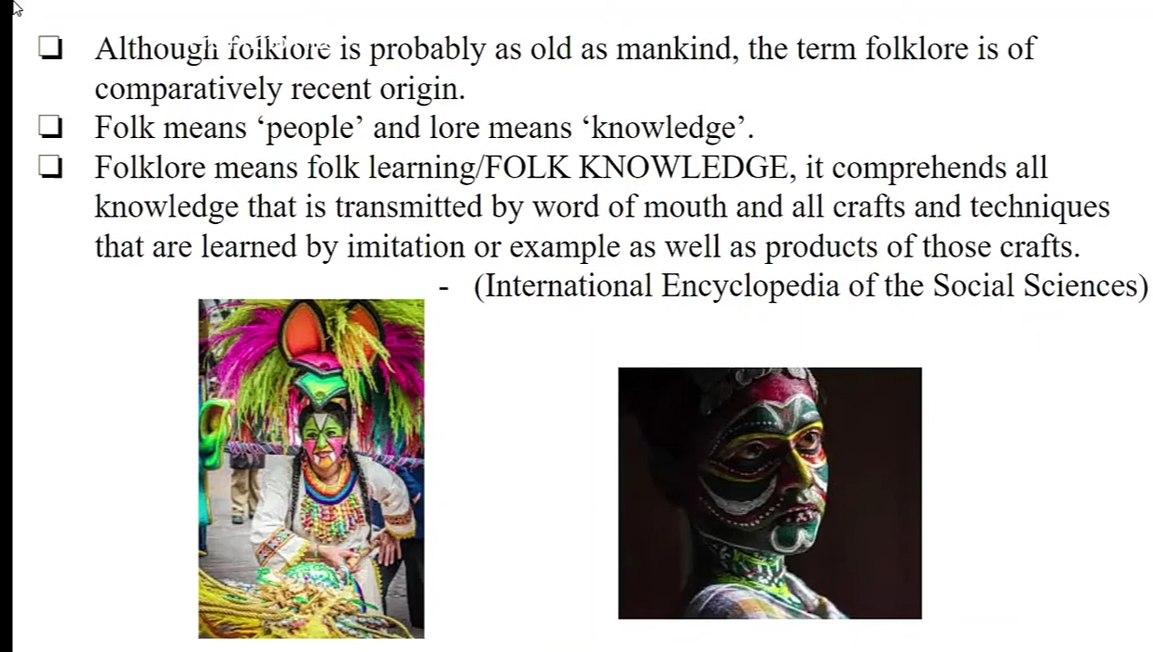

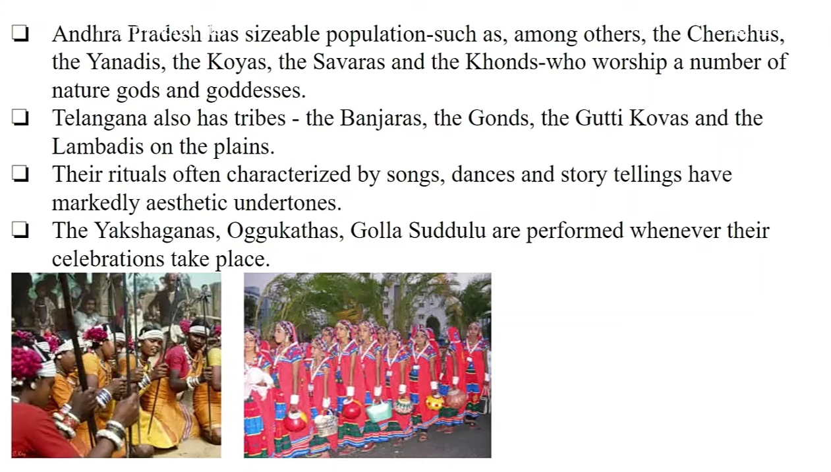

Area/ward:.

I have conducted a community survey project on the topic of performing of arts under the guidance of o.Geetha (M.A TeLuGU) ihave conducted this survey in kothapeta ( v); in c.k dinne (M).

Log book

