SKR & SKR GOVERNMENT DEGREE COLLEGE FOR WOMEN (A)
KADAPA, Y.S.R DISTRICT
NAAC Re Accredited Institution at ‘B’ Level
(Affiliated to YOGIVEMANA UNIVERSITY)
JUNE, 2022

Socio economic survey
(Community Survey Project)
DEPARTMENT OF BOTANY
TITLE OF PROJECT
“ FACILITES OF AGRICULTURAL PRACTICES IN RURAL AREAS ”
Submitted By
D.Sai Mrudula
Ht.NO 21440316004

MENTOR
Dr. P.SUBRAMANYAM, M.Sc, Ph.D
LECTURER IN BOTANY

CERTIFICATE

This is to certify that the project entitled “Socio Economic survey & Facilities of Agricultural in C.K Dinne is the bonafide project work of D. Sai Mrudula (HALL TICKET NO: 21440316004 done under supervision of Dr. P.SUBRAMANYAM, M.Sc., Ph.D., for the Community Service Project in the Department of Botany.

HOD MENTOR

ACKNOWLEDGEMENTS

I extremely grateful to my beloved Principal, Dr. P. Subba Lakshumma. M.Com., M.Phil. Ph.D., SKR & SKR Govt. Degree College for Women(A), Kadapa for my CSP Orientation.
The entire CSP work has been carried out in the Department of Botany, SKR & SKR Govt. Degree College for Women(A), Kadapa, and I expressed my deep sense gratitude and sincere thanks to B.Yugavani Garu, Head of the Department of Botany, SKR & SKR Govt. Degree College for Women(A), Kadapa, for spending her precious time with me in discussing various typical problems relating to this Community Service Project and for her kind co-operation.
My sincere thanks to my Teacher Y.Nagarathnamma Garu, Lecturer in Botany SKR & SKR Govt. Degree College for Women(A), Kadapa.
I express my gratitude for inspiration and Supervision of my Teacher and my CSP Mentor Dr. P.Subramanyam Garu Department of Botany, SKR & SKR Govt. Degree College for Women(A), Kadapa for his guidance for the entire Community Service Project.

CONTENTS

S.No | Topic | Page no
1 | Introduction of Socio-economic survey & facilities of Agricultural practices
2 | Methodology
3 | Report
4 | Photographs
5 | Graphs
6 | Conclusion
7 | Bibliography

Introduction of community service Project
Community Service Project is an experiential learning strategy that integrates meaningful. Community service with instruction, participation, learning and community development. Community Service Project involves students in community development and service. Activities and applies the experience to personal and academic development. Community Service Project is meant to link the community with the college for mutual benefit. The community will be benefited with the focused contribution of the college students for the village/ local development. The college finds an opportunity to develop social sensibility and responsibility among students and also emerge as a socially responsible institution.
Objectives of Community Service Project
- Community Service Project shall be an integral part of the curriculum, as an alternative to the two months of Summer Internships / Apprenticeships / On the Job Training, whenever there is an exigency when students cannot pursue their summer internships. The specific objectives are;
- To sensitize the students to the living conditions of the people who are around them.
- To help students to realize the stark realities of the society.
- To bring about an attitudinal change in the students and help them to develop societal consciousness, sensibility, responsibility and accountability
- To make students aware of their inner strength and help them to find new /out of box solutions to the social problems.
- To make students socially responsible citizens who are sensitive to the needs of the disadvantaged sections.
- To help students to initiate developmental activities in the community in coordination with public and government authorities.
- To develop a holistic life perspective among the students by making them study culture, traditions, habits, lifestyles, resource utilization, wastages and its management, social problems, public administration system and the roles and responsibilities of different persons across different social systems

Importance of Community Survey

A community survey helps you discover your target community’s attitudes, opinions, experiences, and needs.

It is the chief primary research method for garnering community feedback on a scale.

Community surveys provide information on the ethnic makeup of the community, its local languages, cultures, and even lifestyles.

A community survey is an integral part of needs assessment in research.

It leads to high data quality and high response rates because the community members have already shown intent to participate in a research study.

Definition of survey
A survey is a way of collecting information that you hope represents the views of the whole community or group in which you are interested.
Definition of community survey
Systematic gathering of data for a particular purpose from various sources, including questionnaires, interviews, observation, existing records, and electronic devices. The process is usually preliminary to statistical analysis of the data.
Types of Community surveys:

1. Online Community Surveys

2. Community Forums and Closed Groups

3. Location-based Community Surveys

4. One-on-One Interviews/ Surveys

5. Telephone Surveys

6. Cross-Sectional Community Surveys

How to Conduct a Community Survey
1. Outline the goals of your survey
2. Choose your target community
3. Draft your questions
4. Choose a survey method
5. Analyze the responses
Topic of specific domain Project :
Facilities of Agricultural Practices in Rural areas
Introduction:
Vedic literature provides some of the earliest written record of agriculture in India. Rigveda hymns, for example, describes ploughing, fallowing, irrigation, fruit and vegetable cultivation. Other historical evidence suggests rice and cotton were cultivated in the Indus Valley, and ploughing patterns from the Bronze Age have been excavated at Kalibangan in Rajasthan. ("The Story of India: a PBS documentary) Bhumivargaha, an Indian Sanskrit text, suggested to be 2500 years old, classifies agricultural land into 12 categories: urvara (fertile), ushara (barren), maru (desert), aprahata (fallow), shadvala (grassy), pankikala (muddy), jalaprayah (watery), kachchaha (contiguous to water), sharkara (full of pebbles and pieces of limestone), sharkaravati (sandy), nadimatruka (watered from a river), and devamatruka (rainfed). Some archaeologists believe that rice was a domesticated crop along the banks of the river Ganges in the sixth millennium BC.(Roy, Mira (2009). So were species of winter cereals (barley, oats, and wheat) and legumes (lentil and chickpea) grown in northwest India before the sixth millennium BC. Other crops cultivated in India 3000 to 6000 years ago, include sesame, linseed, safflower, mustard, castor, mung bean, black gram, horse gram, pigeon pea, field pea, grass pea (khesari), fenugreek, cotton, jujube, grapes, dates, jack fruit, mango, mulberry, and black plum Indians might have domesticated buffalo (the river type) 5000 years ago ( "Indian Agriculture and IFFCO" 2019).
According to some scientists agriculture was widespread in the Indian peninsula, 10000–3000 years ago, well beyond the fertile plains of the north. For example, one study reports 12 sites in the southern Indian states of Tamil Nadu, Andhra Pradesh and Karnataka providing clear evidence of agriculture of pulses Vigna radiata and Macrotyloma uniflorum, millet-grasses (Brachiaria ramosa and Setaria verticillata), wheats (Triticum dicoccum, Triticum durum/aestivum), barley (Hordeum vulgare), hyacinth bean (Lablab purpureus), pearl millet (Pennisetum glaucum), cotton (Gossypium sp.), linseed (Linum sp.), as well as gathered fruits of Ziziphus and two Cucurbitaceae.( Fuller; Korisettar, Ravi; Venkatasubbaiah, P.C.; Jones, Martink.; et al. (2004).
Some claim Indian agriculture began by 9000 BC as a result of early cultivation of plants, and domestication of crops. Settled life soon followed with implements and techniques being developed for agriculture. (Lal, R. (August 2001). Double monsoons led to two harvests being reaped in one year. Indian products soon reached trading networks and foreign crops were introduced. Plants and animals—considered esses "reeds that produce honey without bees" being grown. These were locally called साखर, (Sākhara). On their return journey soldiers carried the "honey bearing reeds," thus spreading sugar and sugarcane agriculture. (Food and Agriculture Organization, United Nations. 2009.)
People in India had invented, by about 500 BC, the process to produce sugar crystals. In the local language, these crystals were called khanda (खण्ड), which is the source of the word candy. Before the 18th century, cultivation of sugarcane was largely confined to India. A few merchants began to trade in sugar – a luxury and an expensive spice in Europe until the 18th century. Sugar became widely popular in 18th-century Europe, then graduated to become a human necessity in the 19th century all over the world. Sugarcane plantations, just like cotton farms, became a major driver of large and forced human migrations in the 19th century and early 20th century – of people from Africa and from India, both in millions – influencing the ethnic mix, political conflicts and cultural evolution of Caribbean, South American, Indian Ocean and Pacific Island nations. (Mintz, Sidney (1986).
The history and past accomplishments of Indian agriculture thus influenced, in part, colonialism, slavery and slavery-like indentured labour practices in the new world, Caribbean wars and world history in 18th and 19th centuries.

Indian agriculture after independence.
Despite some stagnation during the later modern era the independent Republic of India was able to develop a comprehensive agricultural programme. In the years since its independence, India has made immense progress towards food security. Indian population has tripled, and food-grain production more than quadrupled. There has been a substantial increase in available food-grain per capita.
Before the mid-1960s, India relied on imports and food aid to meet domestic requirements. However, two years of severe drought in 1965 and 1966 convinced India to reform its agricultural policy and that it could not rely on foreign aid and imports for food security. India adopted significant policy reforms focused on the goal of food grain self-sufficiency. This ushered in India's Green Revolution. It began with the decision to adopt superior yielding, disease resistant wheat varieties in combination with better farming knowledge to improve productivity. The state of Punjab led India's green revolution and earned the distinction of being the country's breadbasket. (The Government of Punjab (2004)
The initial increase in production was centred on the irrigated areas of the states of Punjab, Haryana and western Uttar Pradesh. With the farmers and the government officials focusing on farm productivity and knowledge transfer, India's total food grain production soared. A hectare of Indian wheat farm that produced an average of 0.8 tonnes in 1948, produced 4.7 tonnes of wheat in 1975 from the same land. Such rapid growth in farm productivity enabled India to become self-sufficient by the 1970s. It also empowered the smallholder farmers to seek further means to increase food staples produced per hectare. By 2000, Indian farms were adopting wheat varieties capable of yielding 6 tonnes of wheat per hectare. (Brief history of wheat improvement in India" (2011).
With agricultural policy success in wheat, India's Green Revolution technology spread to rice. However, since irrigation infrastructure was very poor, Indian farmers innovated with tube-wells, to harvest ground water. When gains from the new technology reached their limits in the states of initial adoption, the technology spread in the 1970s and 1980s to the states of eastern India Bihar, Odisha and West Bengal. The lasting benefits of the improved seeds and new technology extended principally to the irrigated areas which account for about one-third of the harvested crop area. In the 1980s, Indian agriculture policy shifted to "evolution of a production pattern in line with the demand pattern" leading to a shift in emphasis to other agricultural commodities like oilseed, fruit and vegetables. Farmers began adopting improved methods and technologies in dairying, fisheries and livestock, and meeting the diversified food needs of a growing population.
As with rice, the lasting benefits of improved seeds and improved farming technologies now largely depends on whether India develops infrastructure such as irrigation network, flood control systems, reliable electricity production capacity, all-season rural and urban highways, cold storage to prevent spoilage, modern retail, and competitive buyers of produce from Indian farmers. This is increasingly the focus of Indian agriculture policy.
India ranks 74 out of 113 major countries in terms of food security index. (India: Global Food Security Index".) India's agricultural economy is undergoing structural changes. Between 1970 and 2011, the GDP share of agriculture has fallen from 43% to 16%. This isn't because of reduced importance of agriculture or a consequence of agricultural policy; rather, it is largely due to the rapid economic growth in services, industrial output, and non-agricultural sectors in India between 2000 and 2010.
Agricultural scientist MS Swaminathan has played a vital role in the green revolution. In 2013, NDTV named him one of 25 living legends of India for outstanding contributions to agriculture and making India a food-sovereign country.
Two states, Sikkim and Kerala have planned to shift fully to organic farming by 2015 and 2016 respectively. Electricity rates for agricultural purposes have been discussed extensively over the years.

Problems:
- "Slow agricultural growth is a concern for policymakers as some two-thirds of India's people depend on rural employment for a living.
- Current agricultural practices are neither economically nor environmentally sustainable and India's yields for many agricultural commodities are low.
- Poorly maintained irrigation systems and almost universal lack of good extension services are among the factors responsible.
- Farmers' access to markets is hampered by poor roads, rudimentary market infrastructure, and excessive regulation."
- India has very poor rural roads affecting timely supply of inputs and timely transfer of outputs from Indian farms.
- Irrigation systems are inadequate, leading to crop failures in some parts of the country because of lack of water.
- In other areas regional floods, poor seed quality and inefficient farming practices, lack of cold storage and harvest spoilage cause over 30% of farmer's produce going to waste, lack of organised retail and competing buyers thereby limiting Indian farmer's ability to sell the surplus and commercial crops.
- The Indian farmer receives just 10% to 23% of the price the Indian consumer pays for exactly the same produce, the difference going to losses, inefficiencies and middlemen. Farmers in developed economies of Europe and the United States receive 64% to 81%.
- In 2012, the National Crime Records Bureau of India reported 13,754 farmer suicides. Farmer suicides account for 11.2% of all suicides in India. Activists and scholars have offered a number of conflicting reasons for farmer suicides, such as monsoon failure, high debt burdens, genetically modified crops, government policies, public mental health, personal issues and family problems
Aim & Objectives of the present Study:
The present study is therefore, undertaken to study and collect information regarding Agricultural facilities in rural areas, using a validated questionnaire..
- Implementation of beneficiary oriented schemes for economics upliftment of farming community.
- Undertaking all possible measures to ensure timely and adequate supply of quality inputs and services such as fertilizers, seeds, pesticides, agricultural implements, etc.
- Creating assured irrigation facilities to the farmers through minor irrigation schemes so as to obtain maximum returns from their land.
- Popularizing the use of farmer's friendly bio-fertilizers.
- Motivating farmers to minimize the use of pesticides and to control the environmental pollution with adoption of Integrated Pest Management.
- Motivating farmers for diversification of areas from traditional crops to commercial crops.
- Monitoring soil health and testing of nutrient level of soil samples collected from farmers fields across the State.
- Undertaking measures to provide agricultural credit, crop insurance and helps the farmers in getting remunerative returns for their produce.
- Helping farmers through use of Information & Communication Technology (ICT) applications.

Methodology :
Staff of the Department of Botany discussed and separated in to three student groups from I B.C.H & II B.C.H programmes and decided monitor to each group to one staff and guide to us to prepare a questionnaire to related survey.
Then in our group 13 students of I B.C.H selected Agricultural practices in rural areas. Our group of students was conducted survey in their own villages or nearby villages by questionnaire.
Timeline of work
First week:
Community survey : This includes the door-to-door survey to collection of data in the form of questionnaire. Different age groups, financial status, education qualification, etc are selected for the collection of data. Comparative study of answers was taken up based on questionnaire for this purpose.
Second week:
Community awareness.
Under this programme, an attempt to create the awareness regarding the agricultural facilities providing by Central and State government has been made by the team members individually in their villages.
Third week:
All the data collected has been compiled in the form of project report. This includes the analysis of data. Based on this, definite conclusions are drawn regarding the facilities f agriculture. This includes the graphical representation of the data.
Fourth week:
During the last week of the Community Service Project, a detailed report of the outcome of the 4 weeks work, it includes the presentation of our project work to the internal viva committee at the college level.

Questionnaire for Socio economic Survey
SKR & SKR GOVERNMENT DEGREE COLLEGE FOR WOMEN (A):: KADAPA
DEPARTMENT OF BOTANY
Name of the Student : Registration No :
Semester / Year/ Course/Group :Semester -1/ 2022-23/ B.Sc., (BZC)
Name of the Guide/Mentor and Department : Dr.P.Subramanyam
Community Social Service Project ::Socio-Economic Survey
1. Address of the Family :
2. Family Details:
S.N | Name of the person | Gender | Age | Education | profession

3. Social Status details: (i)Caste: (SC/ ST/BA-A-B-C-D/OC) (iii)Religion:
4. Economic Status details:
(i) Type of House Building: Hut/ Semi Pucca/ Pucca/ Apartment/ Bunglow/ Rented or Own:
(ii) Availability of Agricultural land: Yes/No , If Yes _________ acres
(iii) Names of crops:
(iv) Cattle: Cows ------Ox----------- Buffaloes---------- Sheep/Goats-----------
(v) Do you have own toilet: Yes/No
(vi) Type Cooking fuel used: LPG / Kerosene/ Electricity/ Wood/ others specify
(vii) Do you have vehicle: Two wheeler/ Auto/ Car/ Any other vehicle
5. Health Details:
(i) Diseases in family:
(ii) Do you have Govt. Arogya Sri Card: Yes/No
6. Other Details:
(i) Do You have TV: Yes/No ii) Do You have Dish Connection: Yes/ No
(ii) Channels Watchedregularly:1._______________ 2.______________ 3. __________________
(iii) Do you have Mobile: Yes/No, Mobile Number: Lap top : Yes/No , Internet availability : Yes/No
(iv) Is internet available at home: Yes/ No
7. Name of the Govt. Schemes received:
Jagananna Vidhya Deevena / Jagananna Vasathi Deevena/ Raithu Bharosa / Any other :
8. Any three problems faced in the village:
Place:
Date: Signature of the Mentor Signature of the Student

Topic of specific domain Project :
Facilities of Agricultural Practices in Rural areas

Questionnaire for Topic of specific domain Project
SKR & SKR GOVERNMENT DEGREE COLLEGE FOR WOMEN (A): KADAPA
DEPARTMENT OF BOTANY
Name of the Student: Registration No:
Semester / Year/ Course/Group: Semester -1/ 2022-23/ B.Sc., (BZC)
Name of the Guide/Mentor and Department: Dr.P. Subramanyam
Community Social Service Project: Socio-Economic Survey
1. Address of the Family:
2. Family Details:
S.NO | Name of the person | Gender | Age | Education | profession
3. Social Status details: (i)Caste: (SC/ ST/BA-A-B-C-D/OC) (iii)Religion:
4. Economic Status details:
(i) Type of House Building: Hut/ Semi Pucca/ Pucca/ Apartment/ Bungalow/ Rented or Own:
(ii) Availability of Agricultural land: Yes/No, If Yes _________ acres
(iii) Names of crops:
(iv) Cattle: Cows ------Ox----------- Buffaloes---------- Sheep/Goats-----------
(v) Do you have own toilet: Yes/No
(vi) Type Cooking fuel used: LPG / Kerosene/ Electricity/ Wood/ others specify
(vii) Do you have vehicle: Two-wheeler/ Auto/ Car/ Any other vehicle
5. Health Details:
(i) Diseases in family:
(ii) Do you have Govt. Arogya Sri Card: Yes/No
6. Other Details:
(i) Do You have TV: Yes/No ii) Do You have Dish Connection: Yes/ No
(ii) Channels Watchedregularly:1. _______________ 2. ______________ 3. __________________
(iii) Do you have Mobile: Yes/No, Mobile Number: Lap top: Yes/No, Internet availability: Yes/No
(iv) Is internet available at home: Yes/ No
7. Name of the Govt. Schemes received:
Jagananna Vidhya Deevena / Jagananna Vasathi Deevena/ Raithu Bharosa / Any other:
8. Any three major problems faced in the village:
Place:
Date: Signature of the Mentor Signature of the Student

Report of Socio economic Survey in Chintha Komma Dinne Project :

- According to our survey report, 35 members are OC and only 5 members BC out of 40.
- It is noticed that all members have permanent houses
- Based on our data out of 40 nearly 15members have 3 acres of land, 7 members have 2 acres,6 members have 4 acres,6 members have 5 acres and only 1 member have 7 and 8 acres of land.
- It is found that 18 houses have cattle and 22 houses did not have cattle.
- Based on our survey all of them have own toilet.
- Out of 40 all members are using LPG fuel for cooking purpose.
- According to our data 34 people have own vehicles expect 6 members don’t have any kind of vehicles.
- The study found that up to 4 members have diabetes,1 person has heart disease,1person have chronic Cancer,1person have paralysis and remaining 1person have ulcer.
- According to our survey 32 people are not watching agriculture related channels only 8 members are watching agriculture related channels.

Topic of specific domain Project :
Report of Facilities of Agricultural Practices in Rural areas
- According to my data, present crop in their lands 40 out of 26 Cotton, 2 Red Gram, 1 Coriander, 1 Banana, 1 Chrysanthemum, 1 Bitter guard, 1 Chilly, 4 Sesamum, 2 Paddy, 1 Black gram was found.
- Last year crop from out of 40 Paddy-9, Cotton -8, Red gram-3 Sesamum -2, Tomato -2, Brijal-1, chrysanthemum-2, Turmaric-2, Maize-1, Lemon-1, onion -1, Benes-1 etc were found.
- Last year crop from out of 40 nearly 42% said average of crop yield, 40% of people said that fewer yield and only 7 people said that yield id good.
- According to our data we found that they are using only 18 members of drip system out of 40 cultivars.
- It is notied that only 57.5 % were known that governamet can do soil test of free of cost, moreover only 32.5% done their soil test on free of cost.
- IT is also found that the opinion of expenditure of crop to raise to raise very heigh i.e 30 members out of 40, medium 9 and average only one former.
- Asper data collected from formers 23 candidates said that they knew about free of cost of soil testing the remaining 17 answered didn’t no.
- 22 Formers raised commercial crops & 18 formers raised horticultural crops like Cotton, Chrysanthemum banana, Sesamum, Onion etc
- Based on the data crop of the last year majorly affected by diseases & heavy rains (37) few said lack of knowledge.
- In our area grown mainly commercial crop very few were raised other crops.
- Majority people 28 out of 40 have sufficient storage for their yields. Few have doesn’t have storage facilities.
- All most all formers used pesticides to protect their crops moreover huge number of verities used based on crop.
- 38 out of 40 answered as yes for aware of government schemes only two answered no.

Our team members with Dr. B. Srinivasulu Principal and our staff members
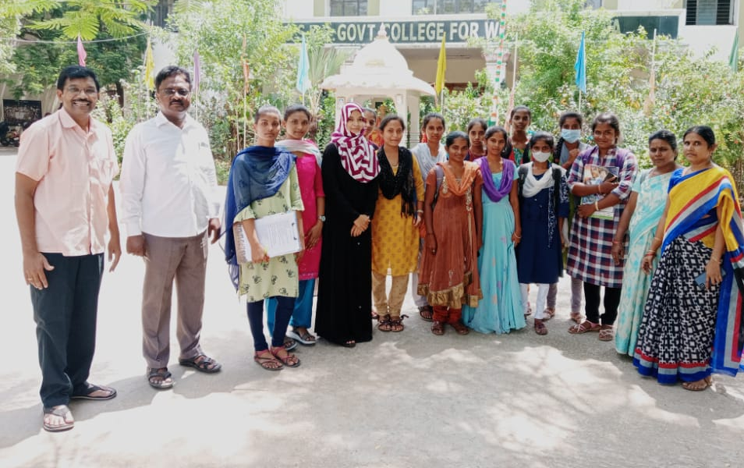
House hold survey in C.K. Dinne
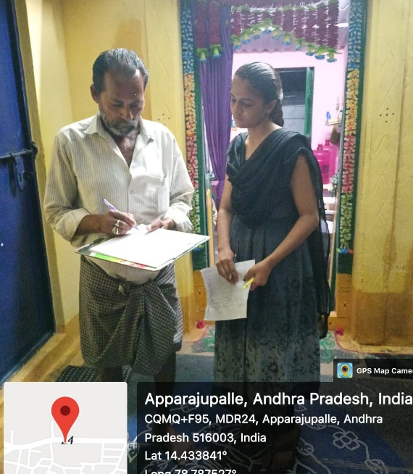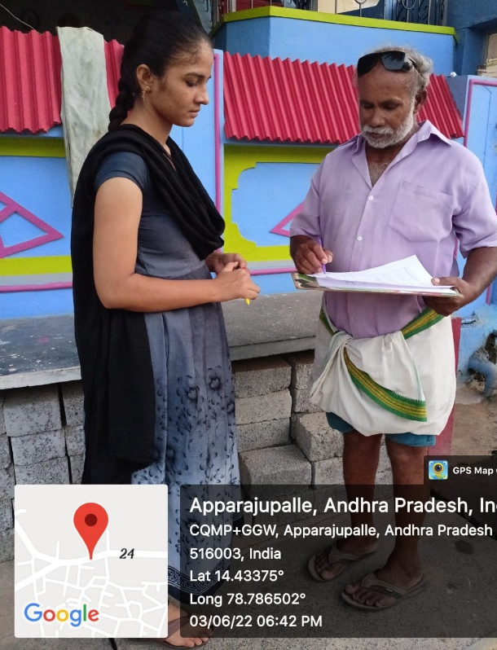

House hold survey in C.K. Dinne
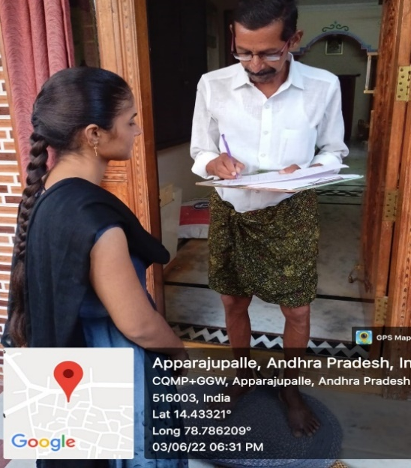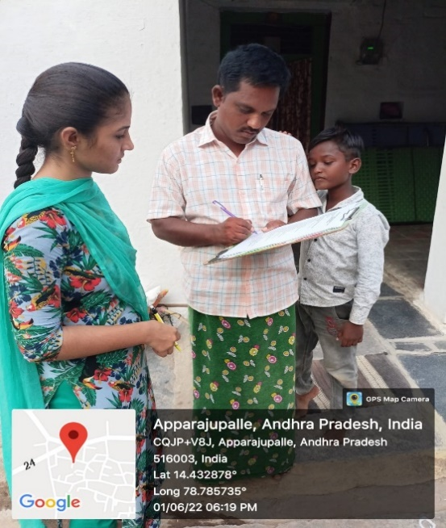
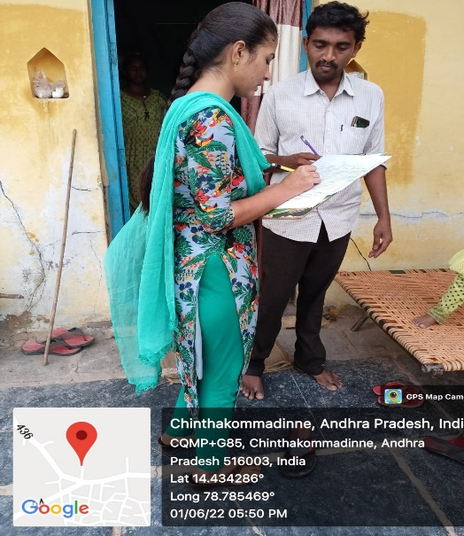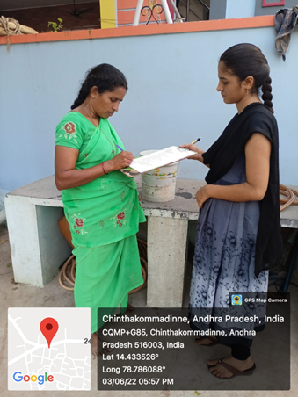
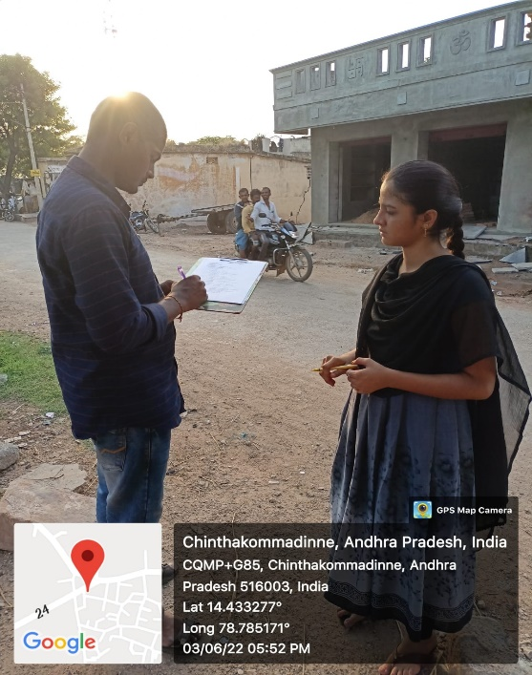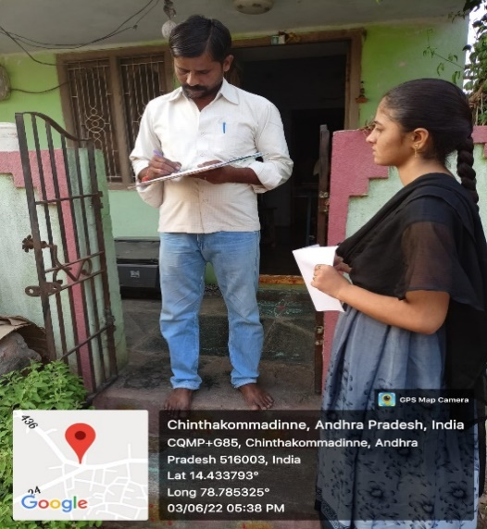
 | Social Status
CK DINNE | TOTAL | OC | BC | OTHERS
CK DINNE | 40 | 35 | 5 | NIL
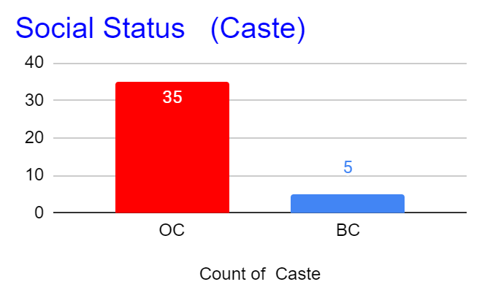
Number of Acres
CK DINNE | TOTAL | 1 | 2-3 | 4-8
CK DINNE | 40 | 4 | 22 | 14
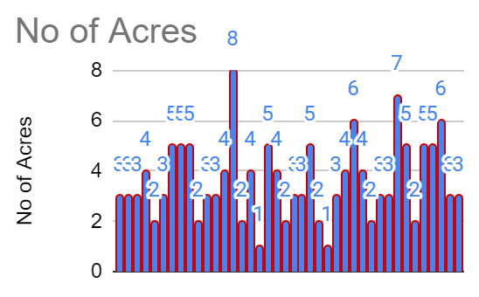
Do you have own vehicle
CK DINNE | TOTAL | Have vehicles | No vehicles
CK DINNE | 40 | 34 | 06
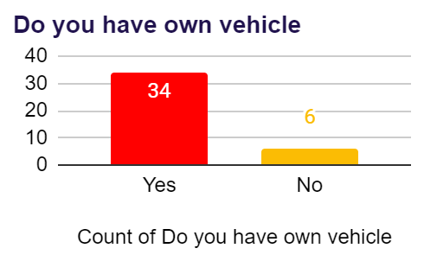
Watching Agriculture channels
CK DINNE | TOTAL | Watching | Not watching
CK DINNE | 40 | 08 | 32
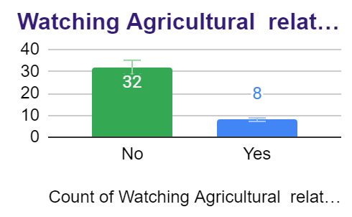
Diseases
CK DINNE | TOTAL | Diabetes | Ulcer | Cancer | Heart Problem | Paralysis
CK DINNE | 40 | 4 | 1 | 1 | 1 | 1

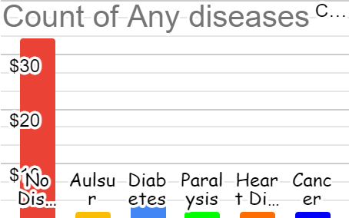
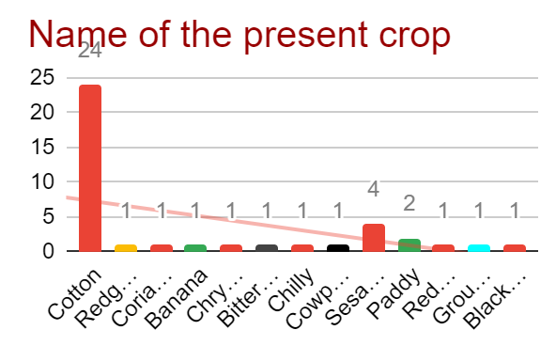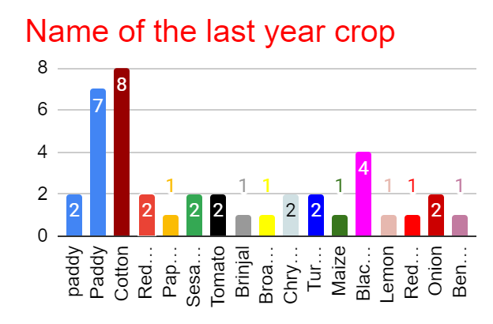

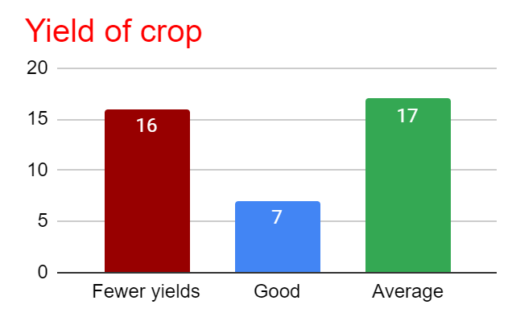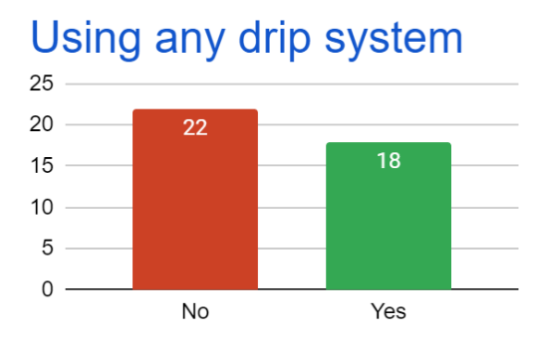

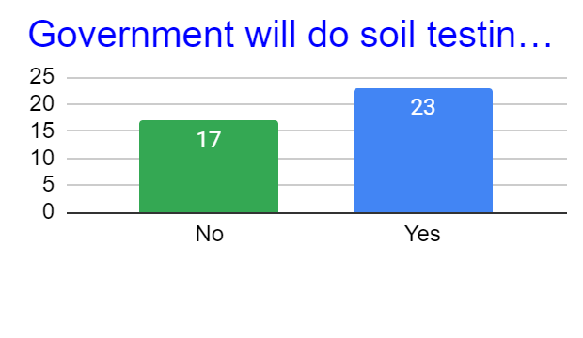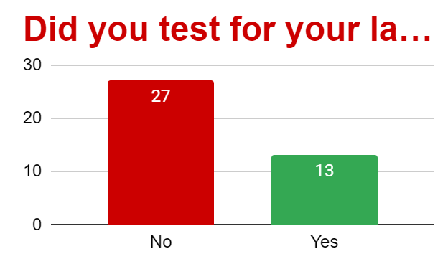
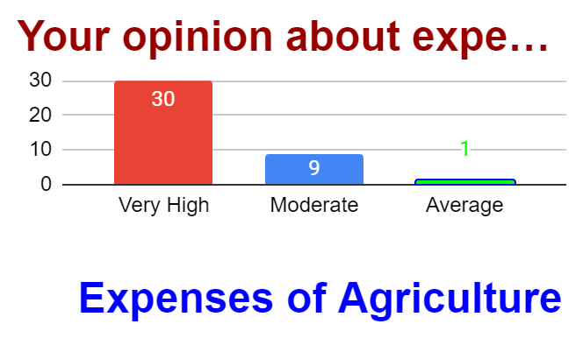
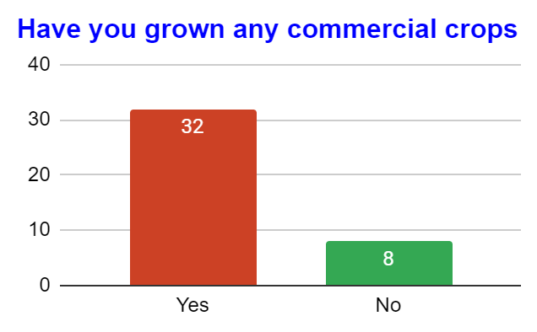
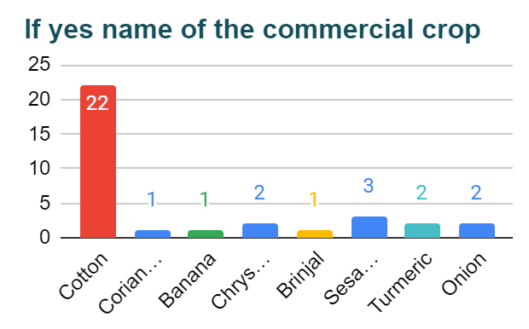

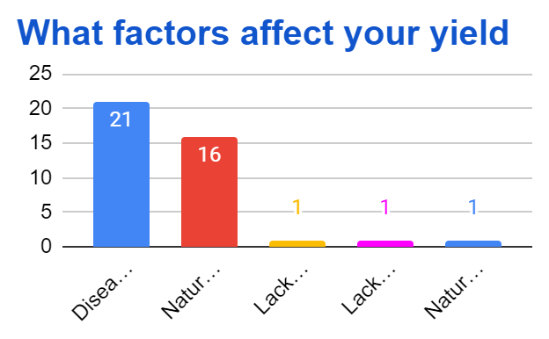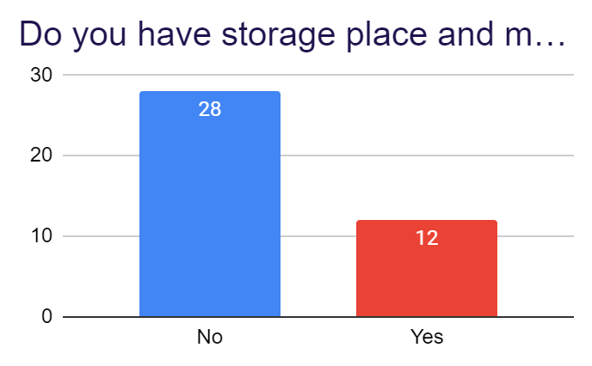

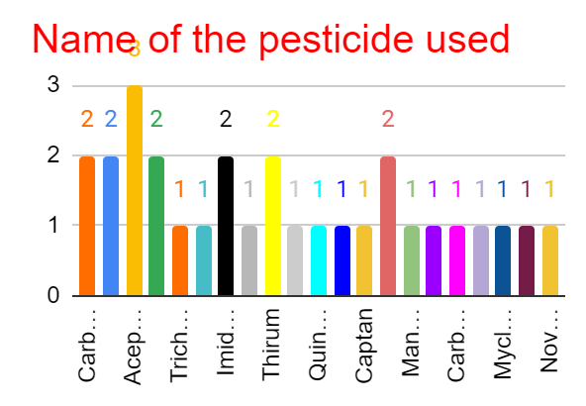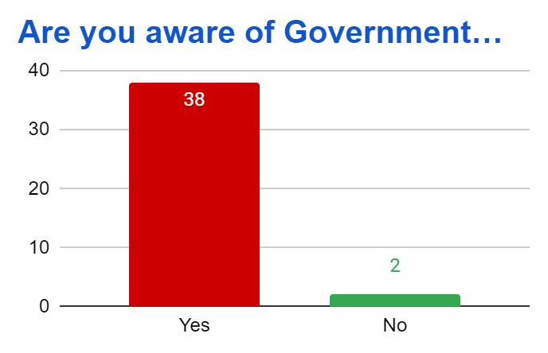

Conclusion:
According to my survey all of them, have permanent house, toilets, LPG gas connection, Arogya Sri cords, mobile phones and A.P. fiber net facilities. Only 8 members are watching agriculture related channels rest of people were not interested towards this type of channels so we aware them to wards agriculture related channels by explaining importance of this channels. 34 members have own vehicles. All they have agriculture fields but only few acres (1-8 only), moreover majority of people have well in health.
By the data we found that, no one is using any kind of bio fertilizers for normal and as well as commercial crops so it is noticed that need of awareness on bio fertilizers and then we conducted awareness on it. No one said their survey numbers to note in our log book, they have some doubts we may misuse it. Even though they knew the government do soil test on free of cost, they didn’t do it because lack of knowledge on micro and macro nutrients in soil. We explained importance of micro and macro nutrients in the soil and how they help to increase yield moreover to reduce unnecessary use of chemical fertilizers.

